Copyright for test papers and marking guides remains with West Australian Test Papers.
Test papers may only be reproduced within the purchasing school according to the advertised Conditions of Sale.
Test papers should be withdrawn after use and stored securely in the school until Thursday 2nd July 2020.


SEMESTER ONE

MATHEMATICS
SPECIALIST
UNIT 1

2020

SOLUTIONS

Calculator−free Solutions

1. (a) (i) −b
(ii) 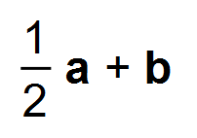
(b) 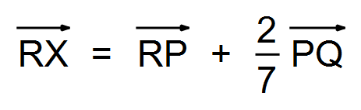
= 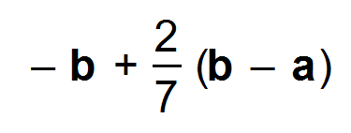
= 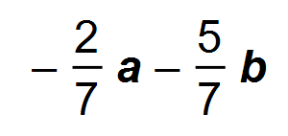 [5]

2. (a) (i) 5
(ii) 21

(b) (i) x = 3
(ii) x = 4
(iii) x = 7
(iv) x = 2

(c) (i) 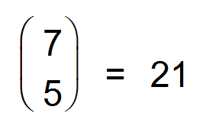
(ii) 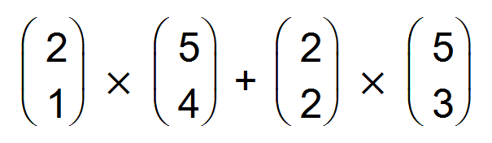
= 20
(d) (i) 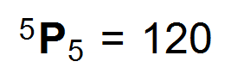
(ii) 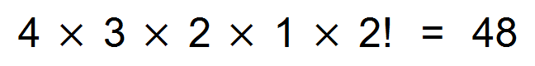 [12]

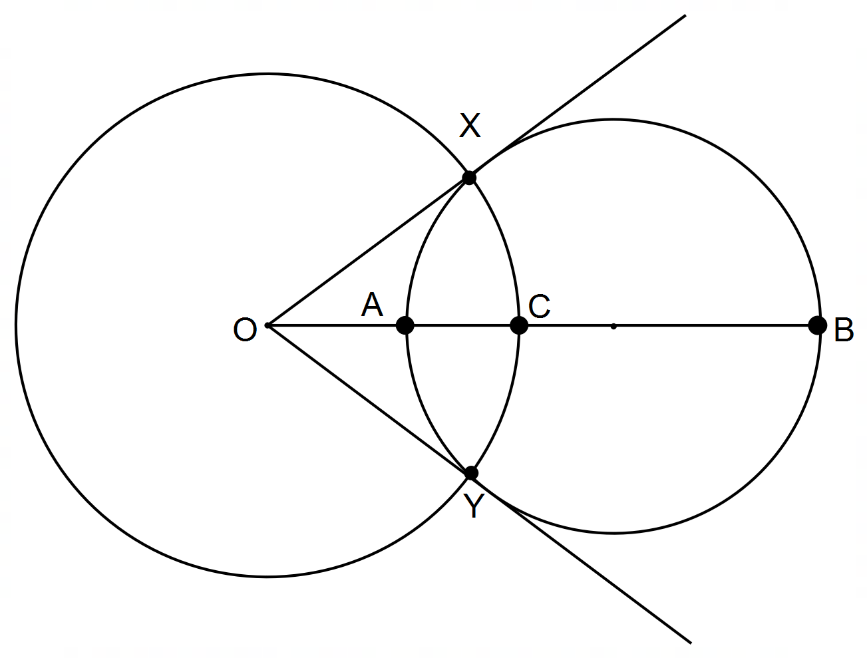3. (a) (i)

(ii) OA x OB = OC²
But OC = OX
∴ OA x OB = OX²
This is the converse of the secant/tangent theorem
∴ OX is a tangent
OA x OB = OC²
But OC = OY
∴ OA x OB = OY²
This is the converse of the secant/tangent theorem
∴ OY is a tangent
(b) 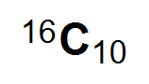 or 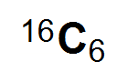
(c) (i) 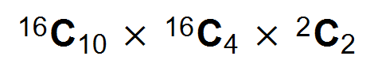
(ii) 3! = 6 ways [10]

4. (a) (i) −i − 13j
(ii) 5
(iii) 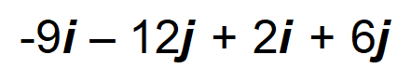
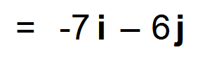
(iv) 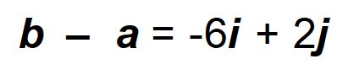
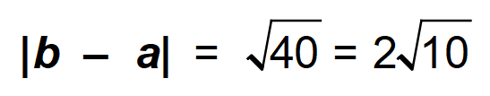
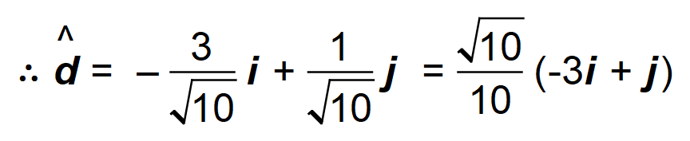
(b) 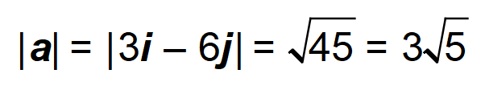
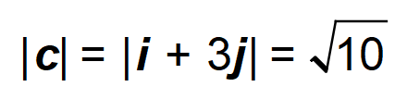
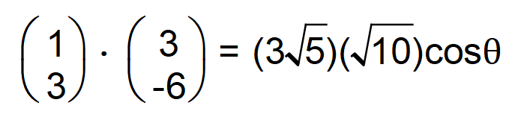
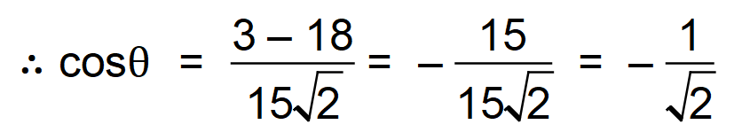
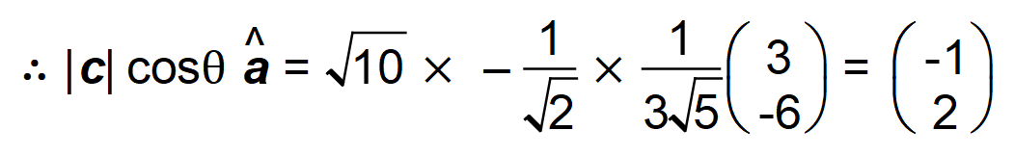
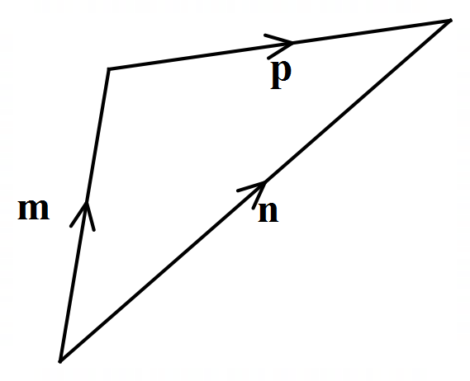 (c)

[12]
5. (a) 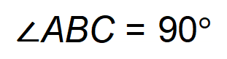
Thale’s Theorem
(b) 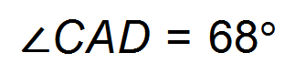
Revolution equal to 360 degrees
(c) 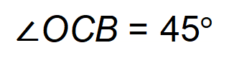
Equal angles at base of isosceles triangle [6]

6. 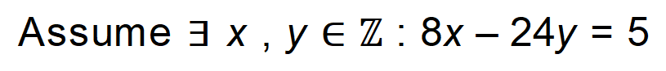
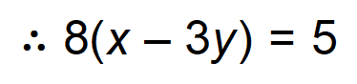
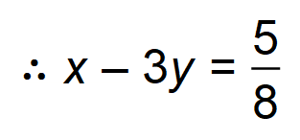
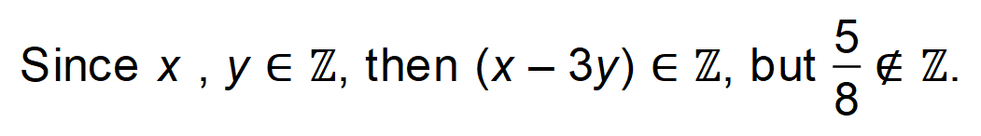
This is a contradiction as (x – 3y) cannot both belong and not belong
to the integer set.

:. False, there are no integers for which this statement is true. [5]

Calculator−Assumed Solutions

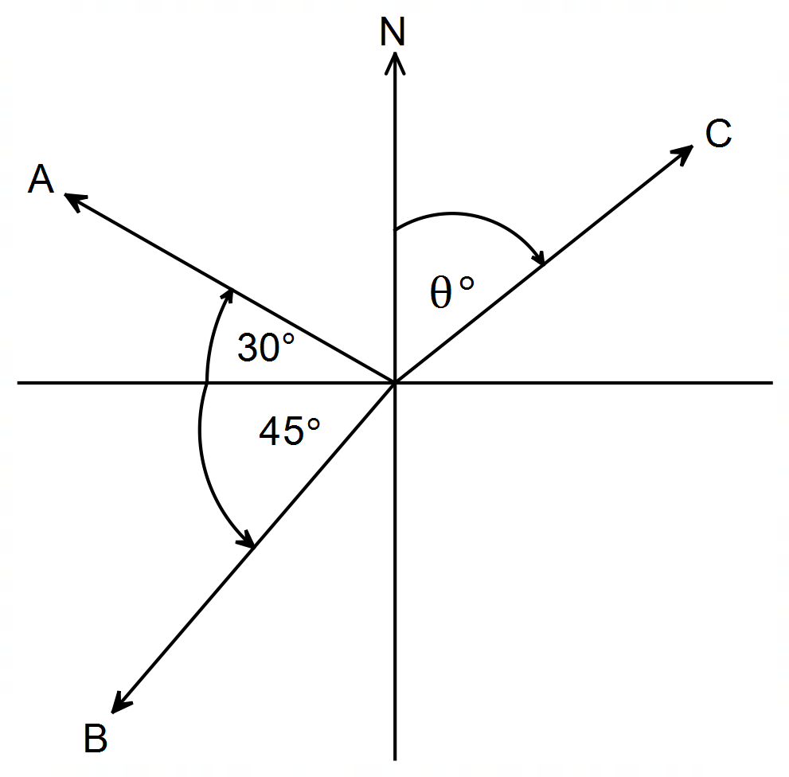7.

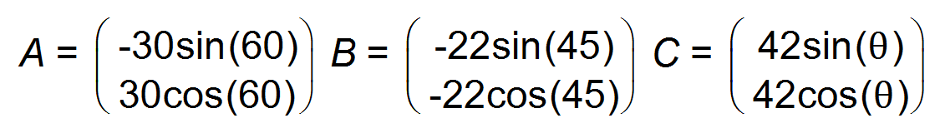
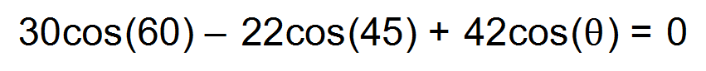
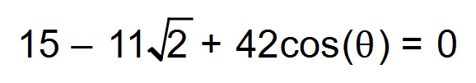
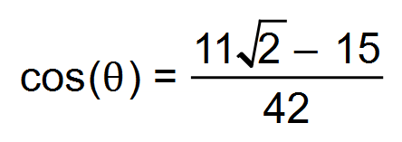
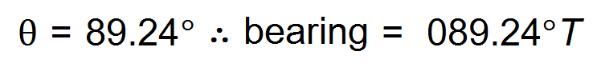
v = 0.46 km/h [6]

8. (a) (i) LM parallel to x–axis so b = 5
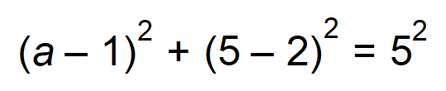
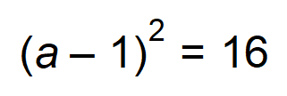
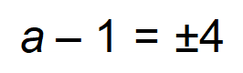
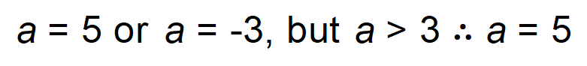
M = (5, 5)
(ii) 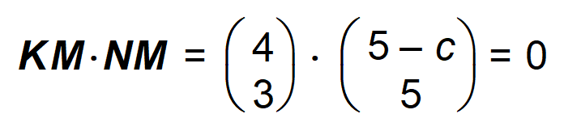
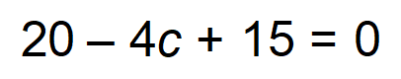
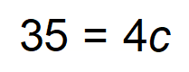
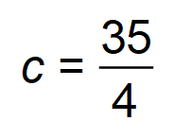

(b) (i) x = 5
y = 2

(ii) If y = 2 & x ≥ 6, then BC // AD
If AB // DC
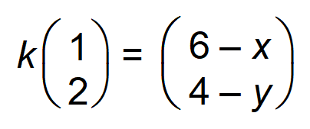
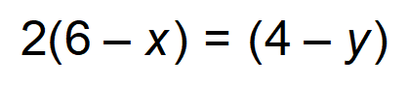
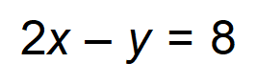
(iii) 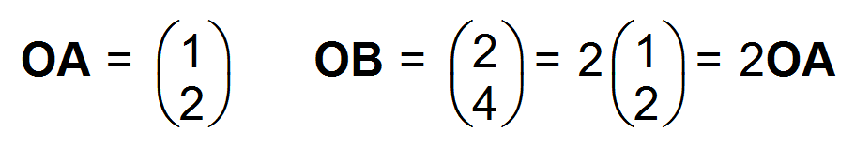
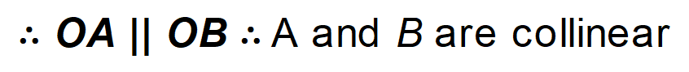 [13]

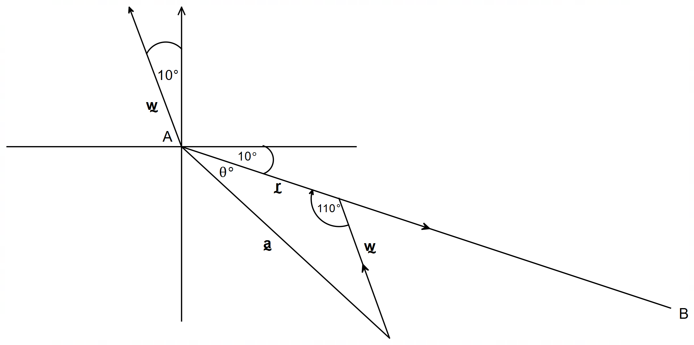9. (a)

(b) 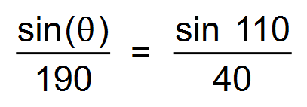
∴ 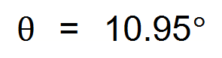
∴ Bearing = 110°T
(c) 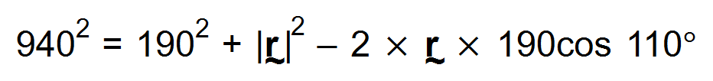
∴ 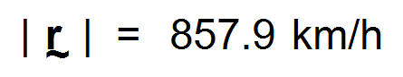
∴ Time taken = 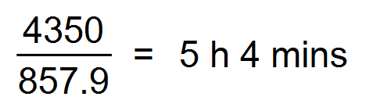 [7]

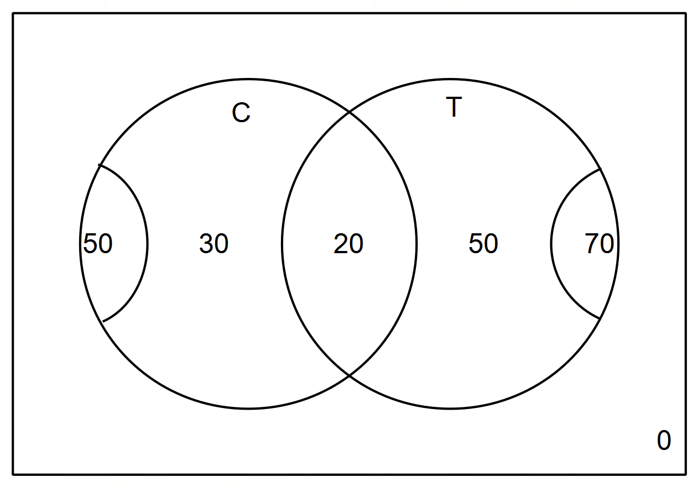10. (a)

∴ 50 like tea only
(b) None like neither
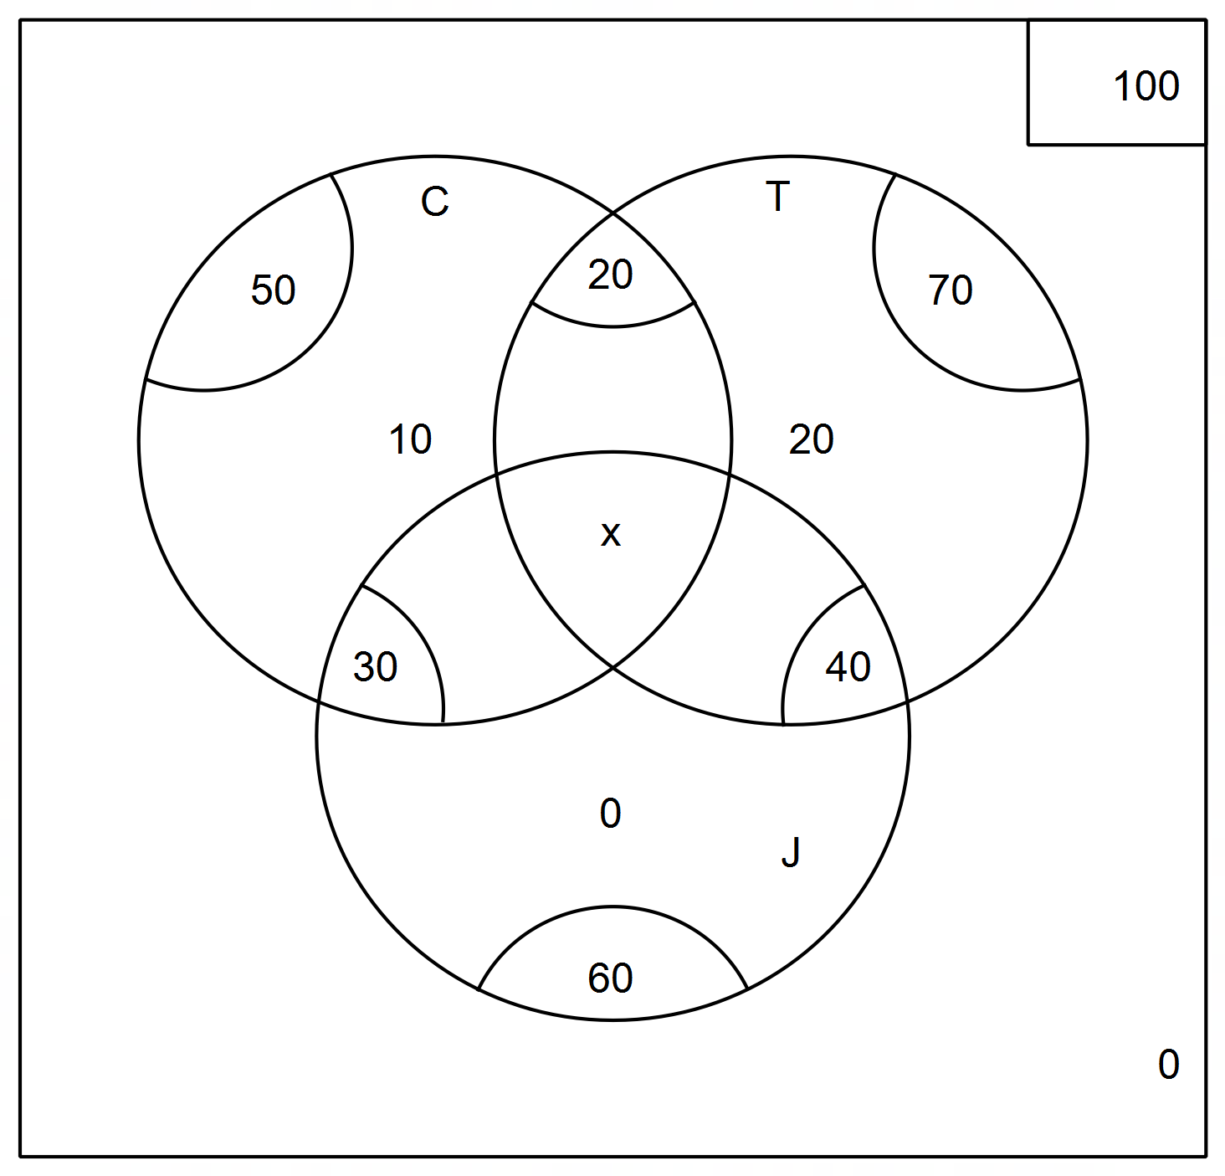 (c)

∴ 100 = 70 + 50 + 60 − 20 − 40 − 30 + x
∴ = 90 + x
∴ x = 10
(d) (i) 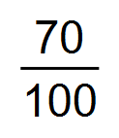
(ii) 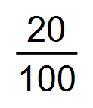
(e) 41 [8]

11. (a) 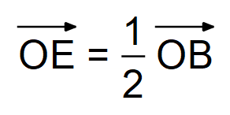
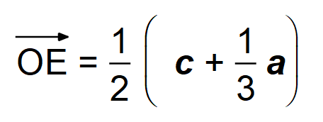
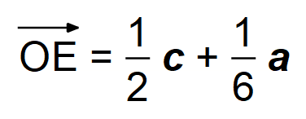
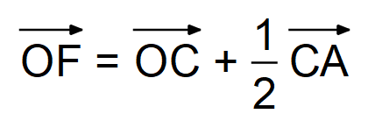
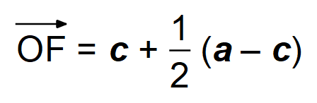
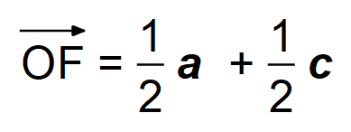
(b) 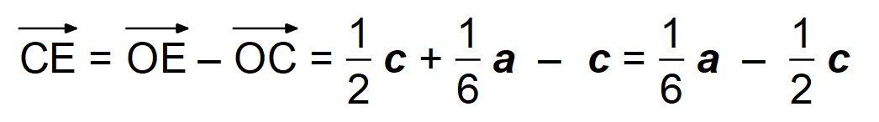
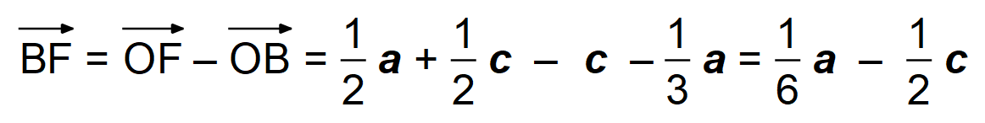
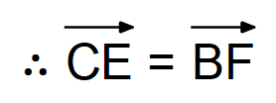
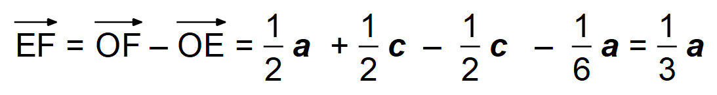
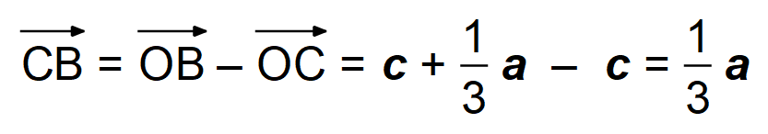 [8]
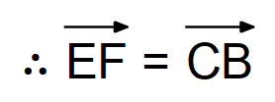

12. (a) 3 > 2 but −3 < −2 is false
(b) “If the triangle is not isosceles, then the triangle does not
have two equal sides.”
Yes is it always true since the original implication is always
true by definition of isosceles triangles.
(c) “If n is divisible by 4, then n is divisible by 8”.
The converse is not always true, as shown by the
counter-example where n = 12
(d) FOR ALL natural numbers p, EXISTS a real number q,
such that q is one less than p. [7]

13. (a)
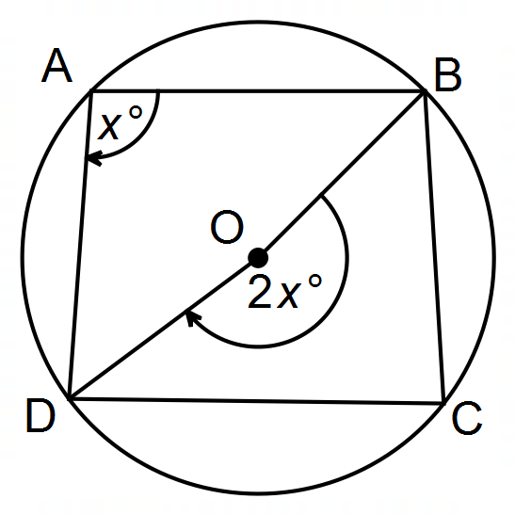

Let ∠BAD = x°
∴ reflex ∠BOD = 2x° Angle at the centre theorem
Similarly let ∠BCD = y°
∴ ∠BOD = 2y° Angle at the centre teorem
Since 2x + 2y = 360
then x + y = 180°
Hence ∠BAD + ∠BCD = 180°
QED
(b) ∠EAG + ∠BCD = 180° Cyclic quadrilateral
∴ ∠EAG ≡ ∠ECF
In ΔEAG and ΔECF
∠AEG ≡ ∠CEF Bisector
∠EAG ≡ ∠ECF Proven
∴ ∠CFE ≡ ∠BFG Vertically Opposite
∴ ∠AGF ≡ ∠BFG QED
(c) (i) Converse
(ii) Yes [10]

14. (a) (i) 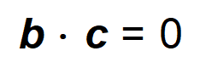
∴ 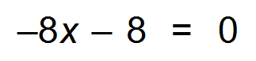
- x = −1

(ii) 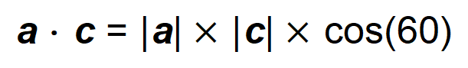
∴ 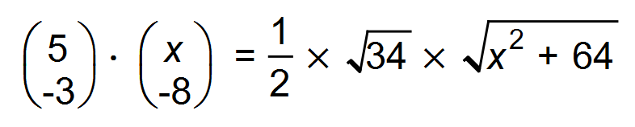
∴ 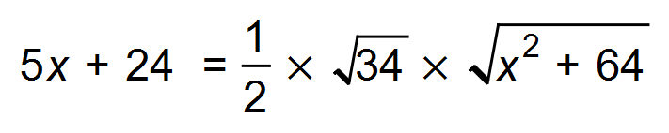
∴ 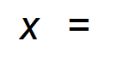 −0.13
(iii) a − b = 13i − 4j
∴ | a − b | = 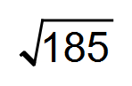
∴ 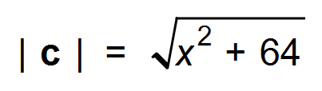
∴ 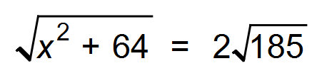
∴ 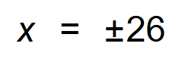

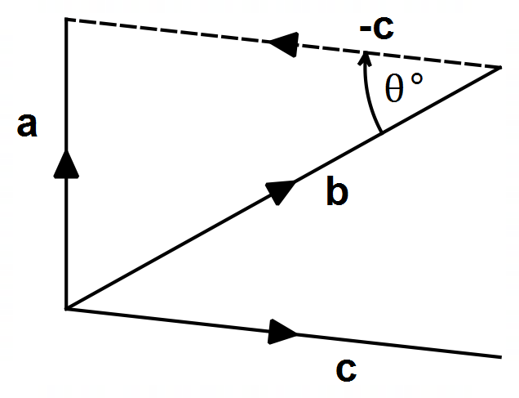(b) (i)

(ii) cos(0) = 1
So, the dot product of a vector with itself is its magnitude
squared multiplied by 1.
(iii) 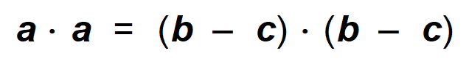
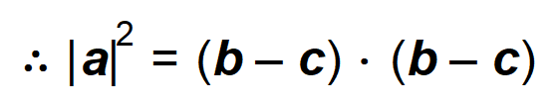
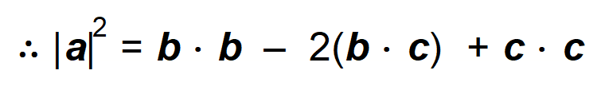
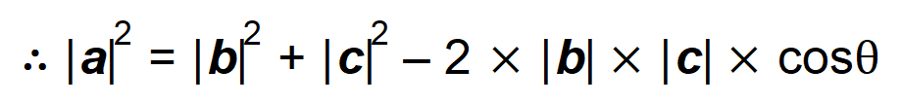
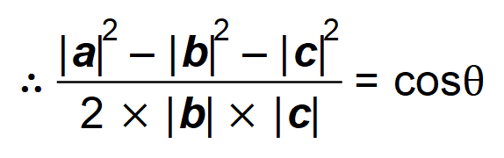 [14]

15. (a) 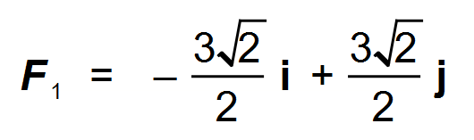
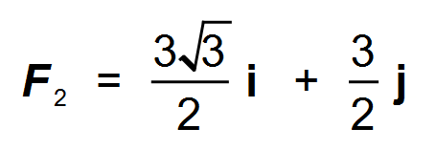
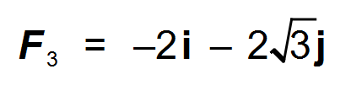
∴ F₁ + F₂ + F₃ = 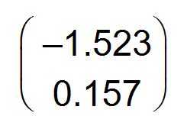
∴ 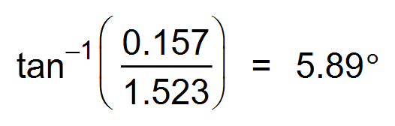
∴ 276°T
(b) a + b = −5i + j
c = 5i − j
| c | = 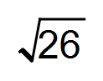
Direction = 101°T [10]

16.
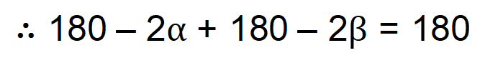
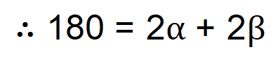
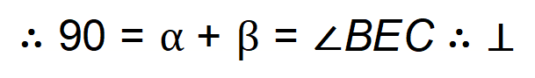 [4]

17. 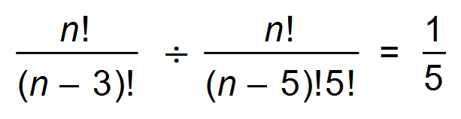
∴ 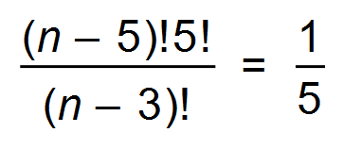
∴ 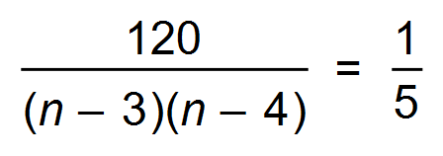
∴ 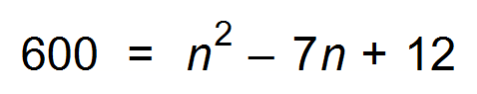
∴ 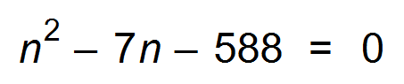
∴ 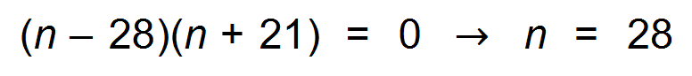 [5]

18. (a) Independent term is the middle term.
∴ 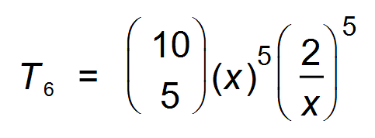
∴ 8064
(b)
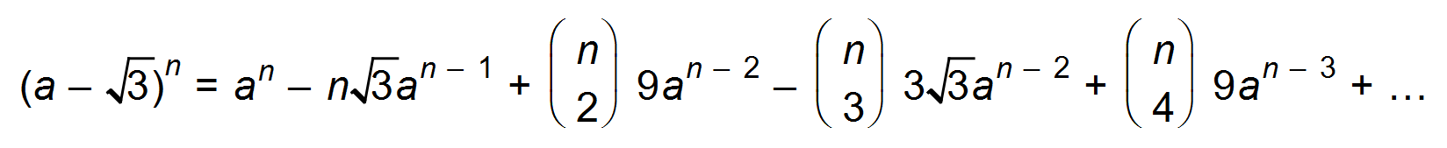
Hence,
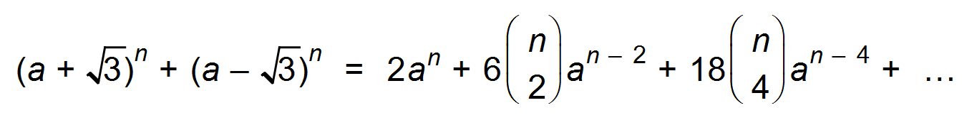
∴ 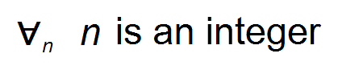 [8]

